Christ’s First Presbyterian Church
353 Fulton Avenue Hempstead, NY 11550
Phone: (516) 292-1644 Fax: (516) 292- 1548
Website: http://www.cfpcny.com

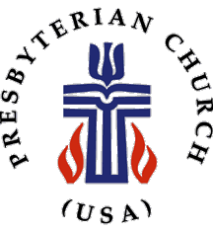

Church Membership Information Form

this application is designed to allow us to obtain important information from you so that we may best serve you and encourage you in the mission of christ’s first presbyterian church.

Personal Information:

Name: Mr. Ms.
Mrs. Dr.
Miss Rev.
(First) (M.I) (Last)

Birthday: (Month/Day)

Home Phone: Work Phone:

Cell Phone:

Address:

City: Zip:

Email:

Occupation:

Spouse’s Name (If applicable)

Children’s Names

My Christian Experience

Briefly tell us about your Christian experience:

Have you been baptized? Date (If known): Where:

In what ministries or church activities have you been involved in the past?

In which area(s) of ministry are you interested in serving?

My Experience at Christ’s First Presbyterian Church

I have been attending Christ’s First Presbyterian Church since

The thing I have enjoyed most about Christ’s First Presbyterian Church is

Christ’s First Presbyterian Church can best minister to me and my family in the following way(s):

How did you first hear about Christ’s First Presbyterian Church?

*** Please return your completed form to the church administrative office

